Small Group Instruction
  - Facilitator Guide

Table of Contents
Course Overview .………………………………………………………………………………………………………………..2
Introduction ………………………………………………………………………………………………………………….…….3
Principles of Small Group Instruction …….……………………………………………………………………….4-5
Principles of Small Group Quiz …………………………………………………………………….………..6
Assembling Small Groups …….………………………………………………………………………………………….7-8
Assembling Small Group Checklist.…….………………………………………………………….………9
Create Conferring Notebook ……....…….……………………………………………………………………….…10-11
Create Conferring Notebook Checklist……………………………..…………………………….…….12
Create Procedures and Transitions …….…………………………………………………………………………13-15
Rotation Sample Lesson …………………………………………………………………………………..……16
Rotation Lesson Template………………………………………………………………………………………17
Create Small Group Lesson …………..…….…………………………………………………………………………….18
Lesson Plan Template …….……………………………………………………………………………….….…19
Closing …….………………………………………………………………………………………………….……………….……20

Course Overview

Are you struggling with implementing small groups into your classroom? In an effort to differentiate instruction in schools many districts are requiring that teachers teach students in small groups to help reach their individual needs. This course is intended to help alleviate some of the stresses of creating groups, tracking student progress, creating procedures for small group expectations, and creating lessons that are easy to differentiate.

Performance Outcomes:
- Recall the principles of small group instruction and its proven success
- Assemble small groups according to academic level
- Create a conferring notebook to track student learning and progress during small groups.
- Generate procedures to be used to introduce students to independent time and expectations
- Create small group lesson that include objectives, “I can” statements, and assessments.

Introduction

20 Minutes Allow students 5 minutes to introduce themselves and why they are taking the course

Introduce yourself, your name, where you are from, how long you have been at your current position and any background information you feel is relevant to the course. Once you have introduced yourself present the following questions to the group and allow each individual to respond.
- What is your name and where are you from?
- Why are you taking this course?
- How long have you been teaching?
- What do you know about small group instruction?
It may be a good idea to note the participants names so that you can refer to them by their name at a later point in the course this will allow for a more personalized experience.
Participants Names:
________________________________________________________________________________________________________________________________________________________________________________________________________________________________________________________________________________________________________________________________________________________________________________________________________________________________________________________________________________________________________________________________________________________________________________________________________________________________________________________________________________________________________________________________________________

Module 2

Principles of Small Group Instruction

10 minutes

At the end of this module the learners will be able to recall the principles of small group instruction and its proven success.
Present the PowerPoint pointing out the following key points on each slide:
 | Slide three and four reviews the benefits of small group instruction. The key takeaway to present to the participants is that students are receiving the one on one instruction that is needed to comprehend specific skills they may be struggling with.
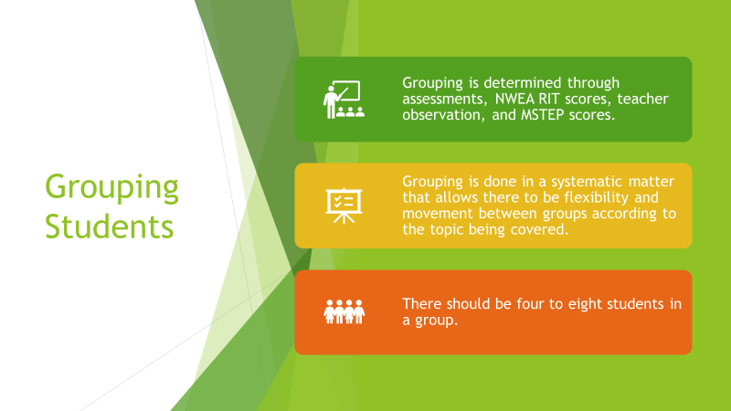 | Slide five identifies the importance of grouping students according to their ability level allowing the student to build on the content as they proceed through the year and avoids the possibility of not understanding the topic or the topic not being challenging enough.
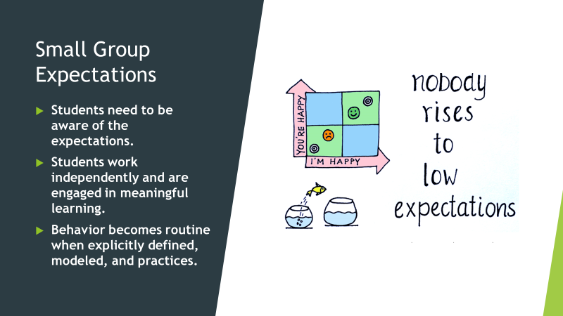 | Slide six reviews the importance of setting expectations for the students to work independently on engaging and meaningful material.
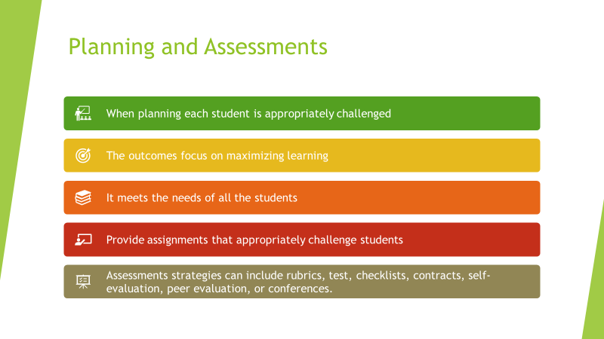 | Slide seven reviews planning and assessments for each small group. The key takeaway for this slide is to focus on the fact that the students need to be assessed on the skill that was practiced ensuring that extra support is provided or that the teacher can move onto new skills.
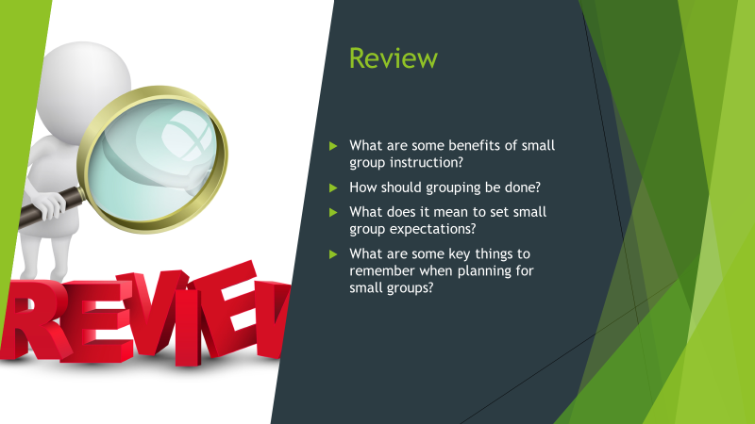 | Slide eight is a review of the content covered and preparation for the quiz that will be administered after the PowerPoint.

Small Group Principles Powerpoint Quiz
Please answer the following questions in complete sentences.

- What are the benefits of small group instruction?
The skills and strategies that are taught during small group instruction are targeted and explicit. Small group differentiated instruction provides systematic comprehensive coverage of the strategies required to move students to greater achievement academically. Targets are determined by student ability.
- How should students be grouped and why?
Grouping is determined through assessments, NWEA RIT scores, teacher observation, and MSTEP scores. Grouping is done in a systematic matter that allows there to be flexibility and movement between groups according to the topic being covered. There should be four to eight students in a group.
- What could happen if clear expectations are not set during small group instruction?
If clear expectations are not set during small group instructions, there will not be learning going on and the room will be chaotic. There could possibly be many interruptions to the teacher’s small groups.
- Why is it important to assess students during small group instruction?
It is important to assess students during small group instruction to maximize learning and provide the students with fluency within their groups. Once they have mastered a skill, they may be able to move to a more challenging group.
- What is the most important thing to remember when teaching in small groups?
Answers may vary but accept anything within reason such as setting clear expectations or grouping students appropriately according to their ability.

Module 2

Assembling Small Groups
  - 30 minutes
The outcomes for this session is for the learner to be able to assemble small groups according to students’ academic level.

Leading question: What are some ways that you may group students for projects?
  - Allow learners time to discuss their strategies
  - Towards the end of the discussion begin relating it to how students will be grouped in small groups.
After discussion project a mock student list for 5th grade and pass out a copy to the learners. Also included with the student rooster will be the RIT scores for determining the level of the NWEA scores. The list will have fictional scores for NWEA testing for reading and math.
Practice Roster Small Group Instruction Intervention RIT Scores
First Name | Last Name | RIT Score Reading | RIT Score Math
Sam | Smith | 192 | 203
Sally | Ford | 205 | 220
John | Brown | 199 | 218
Tim | Perry | 203 | 205
Katie | Holmes | 211 | 174
Brad | Pitt | 183 | 197
Kim | Hedges | 217 | 204
Zoie | Finn | 209 | 218
Doug | Mims | 190 | 199
Joe | Hedges | 199 | 204
Michael | Doe | 202 | 209
Jane | Hatfield | 206 | 212
Fred | Flintstone | 209 | 215
Terrie | Renas | 198 | 204
Greg | Lynch | 197 | 206
Frank | Agnew | 174 | 186
Kristina | Grey | 205 | 210
Lyn | Red | 218 | 225
Gary | Champaign | 220 | 224
David | Joned | 195 | 200
RIT Score Reference Sheet
- Once the learners have had a moment to review the scores, model how to group them according to their ability. Explain that small groups should have 3 to 6 students and their can be up to 5 groups for each subject.
  - If a student scored a 176 in math, they are at a 2nd grade level. If a student scored a 182, they are at the beginning of 3rd grade math level. These students can be grouped together.
  - Model grouping the rest of the students according to their scores for English Language Arts (ELA) and math.

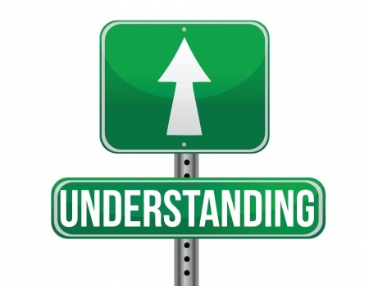

Use the following check list to assess whether or not the teachers understand the strategies of grouping students according to ability.
Small Group Assembling Checklist
Check () Yes or No
PROCEDURE STEPS | Yes | No | COMMENTS
Using the mock student rooster learners will group students into five groups of three to six students. Students will be grouped according to how their RIT scores in math and reading. Learners should have different groups for math and language arts.
- Created two sets of groups, one for math and one for language arts.
- Students are grouped according to their RIT scores.
- Each group has three to six students.
  - Recommendation: Satisfactory ______ Unsatisfactory ______
Unsatisfactory (Must document how the student was unsatisfactory on the reverse side of this form)
Student: Date:
Instructor: _______________________ Date:

Module 3

Creating a Conferring Notebook
  - 30 minutes
The learning outcome is to be able to create a conferring notebook to track student learning and progress during small groups.
Leading question: What are some ways that you track student progress?
  - Write the responses on the board. Bring the conversation around to tracking a classroom where there are 5 groups learning at varying grade levels and standards.
Pass out a binder to each learner. The binder should include dividers and a fictional classroom grid sheet using the students that were used in the previous module.
- Explain that using the binder to track students’ progress will allow the teacher to stay organized when teaching such a wide range of students.
- The binder should have a divider for each group and a class grid for each group.
- On the grid the teacher should include the standard that they are working on for the week and include the students’ progress using the three-check strategy.
  - Introduce the strategy of using check + for mastery, check for proficient, and a check – for emerging learners.
First Name | Last Name | CCSS.ELA-LITERACY.RI.5.1 | CCSS.ELA-LITERACY.RI.5.1 | CCSS.ELA-LITERACY.RI.5.1 | CCSS.ELA-LITERACY.RI.5.1 | CCSS.ELA-LITERACY.RI.5.1
Sam | Smith | -
Sally | Ford
John | Brown | - |  |  | + | +
Tim | Perry |  |  | + | + | +
Katie | Holmes |  |  | + | + | +
Brad | Pitt |  |  |  | + | +
Kim | Hedges |  |  |  | + | +
Zoie | Finn | - | - | - | + | +
Doug | Mims |  |  |  |  | +
Joe | Hedges |  |  |  |  | +
Mike | Doe |  |  | + | + | +
Jane | Hatfield | - | - | - | - | -
Fred | Flintstone |  |  | + | + | +
Terrie | Renas |  |  |  |  | +
Greg | Lynch | - |  |  |  | +
Frank | Agnew |  |  |  |  | +
Kristina | Grey | - | - | - | - | -
Lyn | Red |  |  |  |  | +
Gary | Champaign | - |  |  |  | +
David | Joned | - |  | + | + | +

- Once the teachers have reviewed the example binder, they will create their binder for their own classroom. They should create two binders one for ELA and one for math.

After the teachers create their conferring notebook use the following checklist to ensure that they have included each component.
Conferring Notebook Checklist
Check () Yes or No
PROCEDURE STEPS | Yes | No | COMMENTS
Learner should create two binders one for math and language arts. Each binder should contain a divider for each group. There should also be a class grid within each divider. Class grid should have standard to be working on during the week.
- Created two binders, one for math and one for language arts
- Included a labeled divider for each group
- Each divided section includes a class grid to monitor student progress and identify standards being met for the week.
  - Recommendation: Satisfactory ______ Unsatisfactory ______
  - Unsatisfactory (Must document how the student was unsatisfactory on the reverse side of this form)
Student: Date:
Instructor: _______________________ Date:

Module 4 Creating a Procedures and Transitions
  - 60 minutes
After this module learners will be able to generate procedures to be used to introduce students to independent time and expectations.
Leading question: Why is it important to practice procedures and expectations for small group instruction?
- Present the following PowerPoint
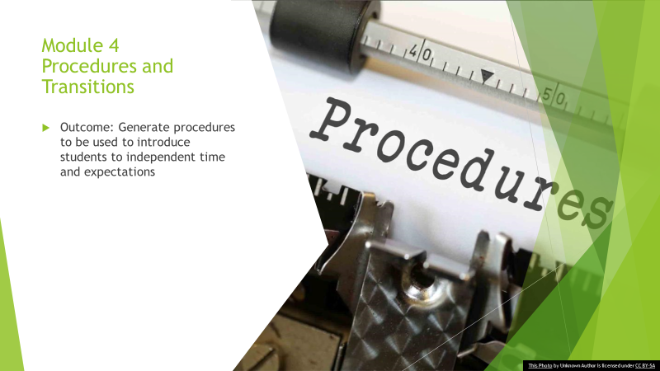 | Slide ten identifies the modules outcome: Generate procedures to be used to introduce students to independent time and expectations.
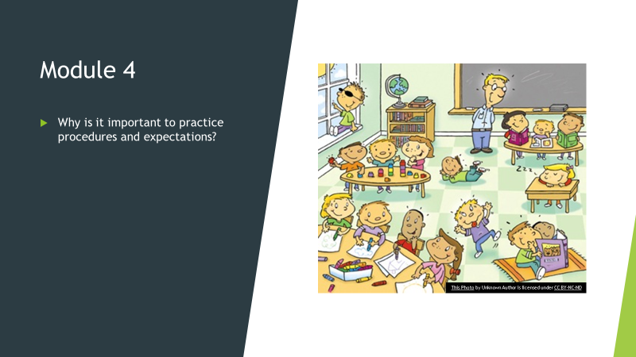 | Slide 11 is the discussion slide  Leading Questions: Why is it important to practice procedures and expectations for small group instruction?  Allow learners to discuss the question and record their points on the board.  Once the discussion wraps up play the following videos of a class with smooth transitions and a class that does not have smooth transitions.
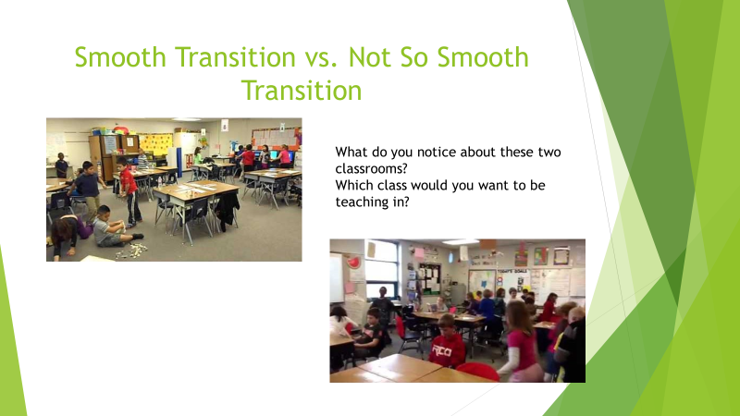 | Play the two videos on slide twelve and have the learners discuss the differences of the two classrooms and which classroom they would rather be teaching in.
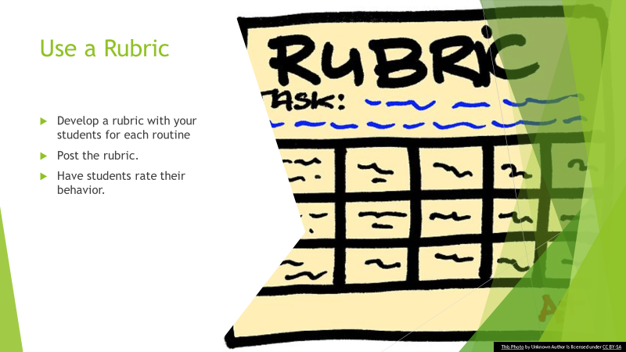 | Slide 13 provides how to create a rubric for small groups and what should be done with the rubric to hold students accountable. Elaborate on these points:  - Develop a rubric with your students for each routine  - Post the rubric.  - Have students rate their behavior.
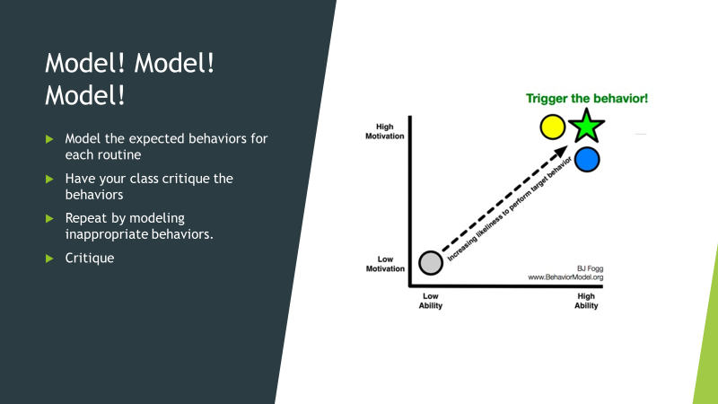 | Slide 14 explains the importance of modeling the behavior. If students do not see the expected behavior, they will not no what it looks like. It is important that the teacher show the appropriate behavior and the inappropriate behavior during transitions.  - Model the expected behaviors for each routine  - Have your class critique the behaviors  - Repeat by modeling inappropriate behaviors.  - Critique
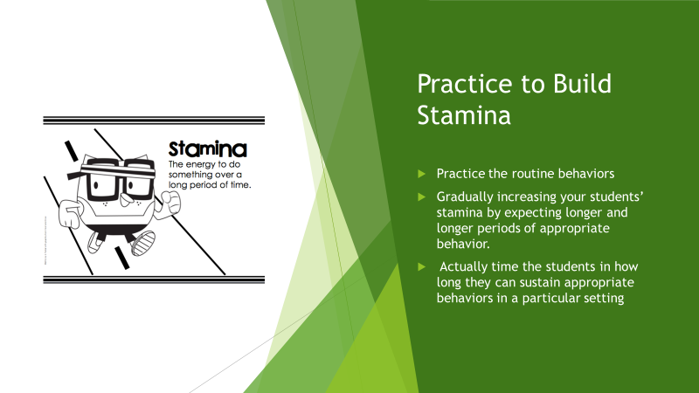 | Slide 15 explains the importance of students practicing the behavior. It is important for students to practice the behavior over and over again so that it becomes habit.  - Practice the routine behaviors  - Gradually increasing your students’ stamina by expecting longer and longer periods of appropriate behavior.  - Time the students in how long they can sustain appropriate behaviors in a particular setting
Slide 16 provides examples of signals to use for transitions. If a teacher is yelling to switch the students may not transition as smoothly. The best tools use to signal a transition is a noise of some sort.
- Use a bell, timer, or other signal
- Train students to move when they hear the sound.
- Post a rotation chart in the classroom so students know where they go and when.

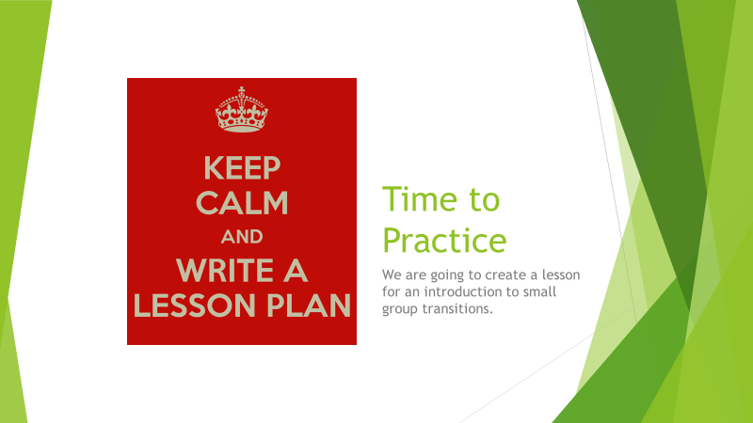 | For slide 17 you will stop and present to the learners a lesson that can be used to teach students a small group transition.
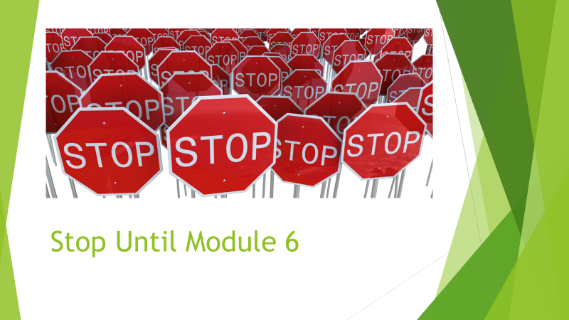 | Slide 18 stop until Module 5

Present the following lesson to the learners:
Rotations Lesson

Outcome:
Students will be able to transition between rotations on the que of a chime.

CONNECT
Ask students what could happen if there are no rules at school or at home
TEACH
The teacher shows the students the chime that they are going to use to signal them to rotate to a different station. Explain to the students where each rotation is and what they will be doing. To begin their can be four stations.
- Chromebook
- Silently Reading
- Work on Writing
- Teacher Table.
Have students sit in their assigned groups.
Play the chime a few times so that they know what to listen for.
Model for the students yourself rotating from station to station once the chime is played.
Be sure to model the right way and the wrong way to transition.

ACTIVE ENGAGEMENT
Once the students are at an assigned rotation for about one-minute play the signal and time the students on how long it took them.
Set a goal for 20 seconds. After practicing the routine four times have the students rate themselves.
Closing
The teacher reiterates what has just been taught, adding it to student’s growing repertoire. Students are reminded that today’s lesson pertains not only to today, but to every day and that this will be the procedures that are used during rotations.

Once the lesson has been reviewed allow the learners to create their own lesson to use in their classroom using the following template.
Rotations Lesson

Outcome:

CONNECT

TEACH

ACTIVE ENGAGEMENT

Closing

Module 5 Create Small Group Lesson
  - 60 minutes
After this module learners will be able to create small group lessons that include objectives, “I can” statements, and assessments.
Introduction:
- Discuss what the learners noticed about the teacher’s lessons.
- Pass out a template for small group lesson plans, included on the template is a section for standards, objectives, content, and assessment.
- Model creating an ELA small group lesson.
Use one of these lessons to model:
DAY | Standards and Objective | I can Statement | Lesson
Tuesday | RI.6.6-Determine an author's point of view or purpose in a text and explain how it is conveyed in the text. | I can identify specific details an author uses to develop his/her point of view in an informational text. | - Review author's point of view  - Read EARTH DAY articles and compare author's point of view  - Assessment Ask the following questions  Ex: What is the author trying to say? Ex: Why do you think the author used the following phrase? Ex: What is the author’s purpose in writing this text?
Wednesday | RI.6.6-Determine an author's point of view or purpose in a text and explain how it is conveyed in the text. | I can explain how an author’s purpose is conveyed, citing evidence from the text. | - Read two articles about whether animals should perform in the circus  - Answer question sets  Assessment: Question sets
Thursday | RI.6.6-Determine an author's point of view or purpose in a text and explain how it is conveyed in the text. | I can explain how an author’s purpose is conveyed, citing evidence from the text. | - Read Why Do What are Stars? Lexile 290L  Assessment:  Using the selected passage, students write a summary or essay citing textual evidence to support their analysis of author intent.

Learners will create week one lessons for their small groups including differentiated instruction for each group and all the components of the lesson plan template.
Allow the the learners to create their weeklong lesson for ELA using the following template:
Assessment will be the WEEKLONG lessons
DAY | Standards and Objective | I can Statement | Lesson
Tuesday
Wednesday
Thursday

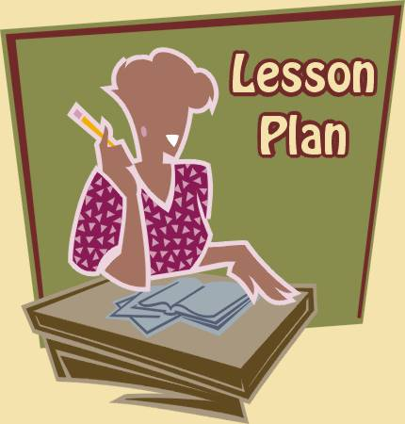

Module 6

Closing
  - 10 MINUTES
At the end of this module the learners will have the tools they need to implement small group instruction in their classroom.
Short PowerPoint on procedures of grouping students according to level, track student progress in small groups, implement transitions procedures and expectations, and create lessons for small groups.
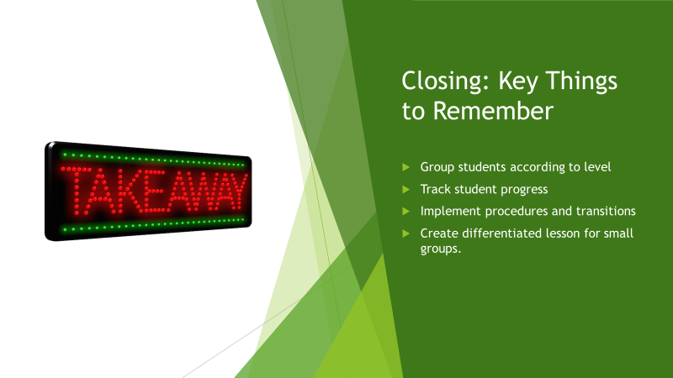 | Slide 19 review the main points of the course  - Group students according to level  - Track student progress  - Implement procedures and transitions  - Create differentiated lesson for small groups.
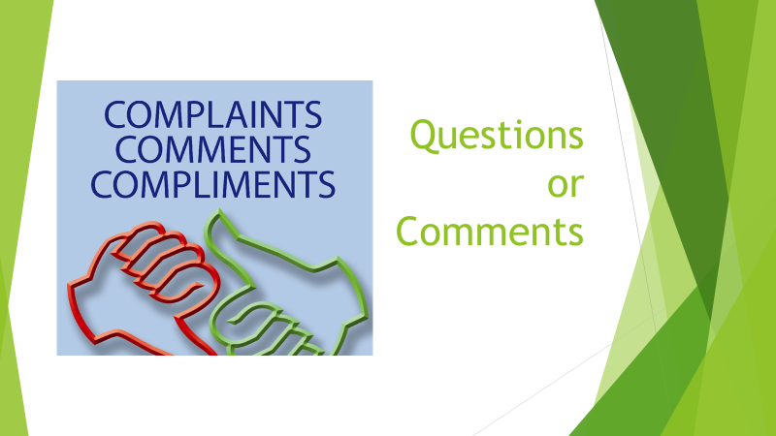 | Slide 20 allows the learners to ask any last-minute questions or comments.
Close out the session by thanking everyone for coming.

